Castle Cary Holiday Park
WILLERBY PINEHURST LODGE

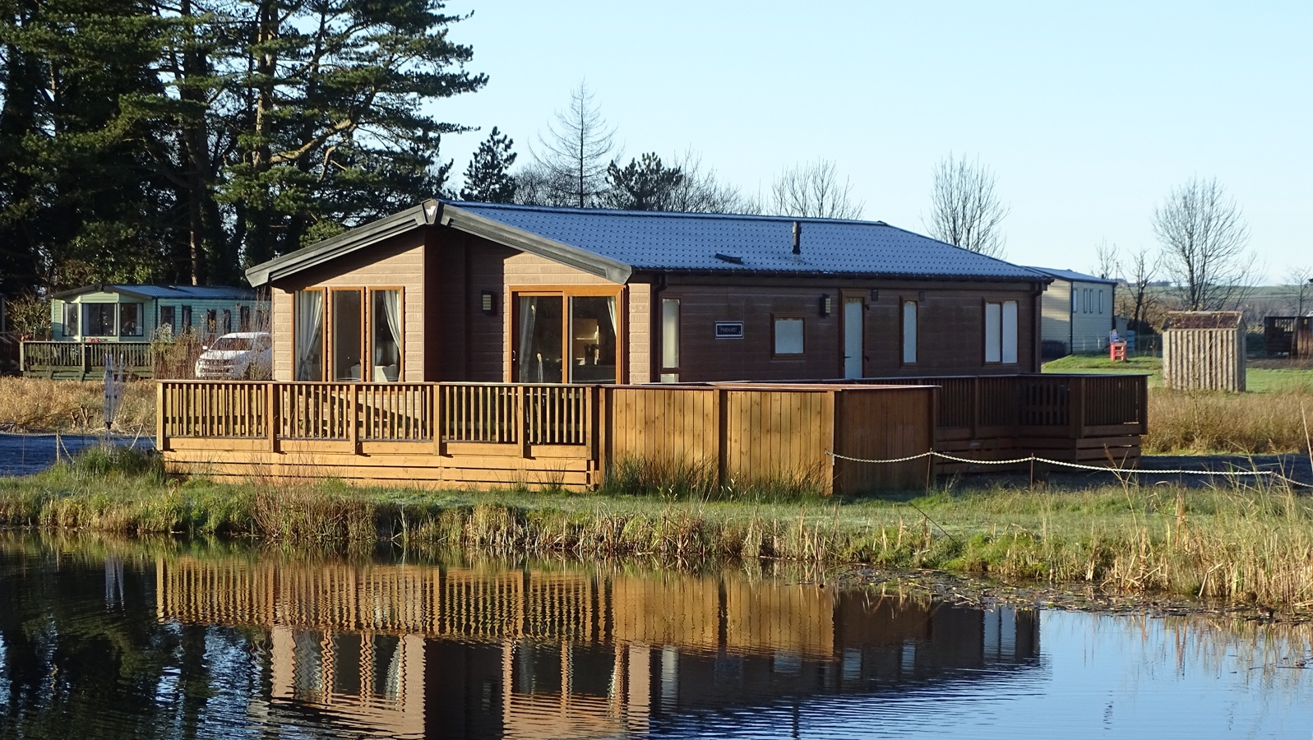
P.O.A
Castle Cary holiday park offers for sale this beautiful 2019
Holiday Lodge

- Lounge/Kitchen/Dining  - Three Bedrooms  - Master En-Suite  - Family Bathroom  - Timber Decked overlooking Loch Murray | - Utility room  - Hot tub  - Parking Spaces  - LPG Gas Central Heating  - Viewing Highly Recommended
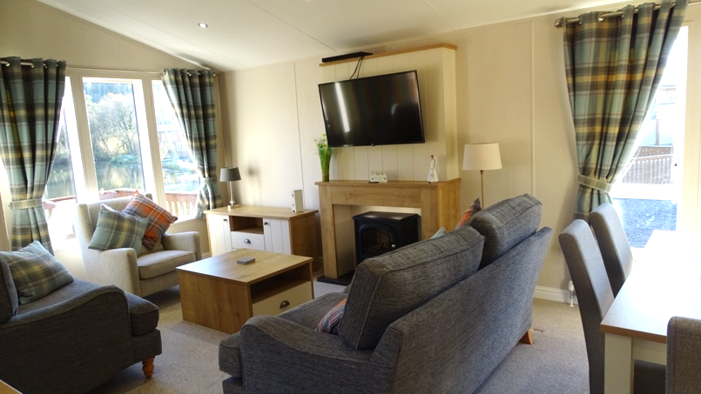
Lounge Area: With a proper three-piece suite arranged around a cosy, modern electric fire, the Pinehurst’s lounge is perfect for entertaining friends and family. Naturally, there’s a media unit for your TV and plenty of storage space.
The front window offers a lovely view to the Loch.
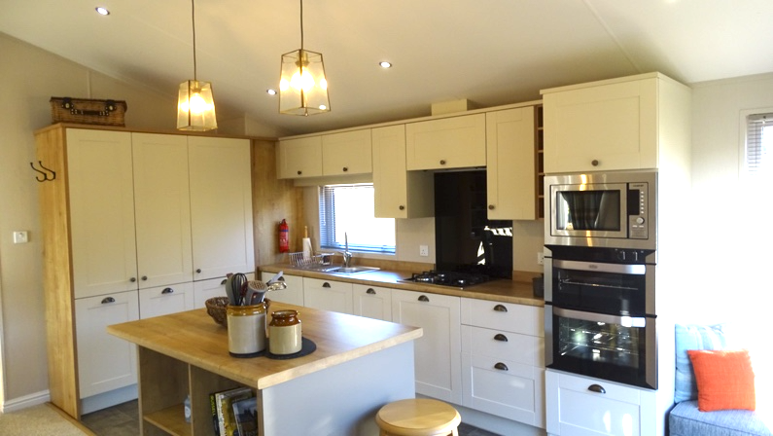
Kitchen /Breakfast Area: This kitchen is fully equipped with integrated appliances, including a full size dishwasher and a built in pantry. The breakfast bar provides a central working environment with cupboards and display shelving below.
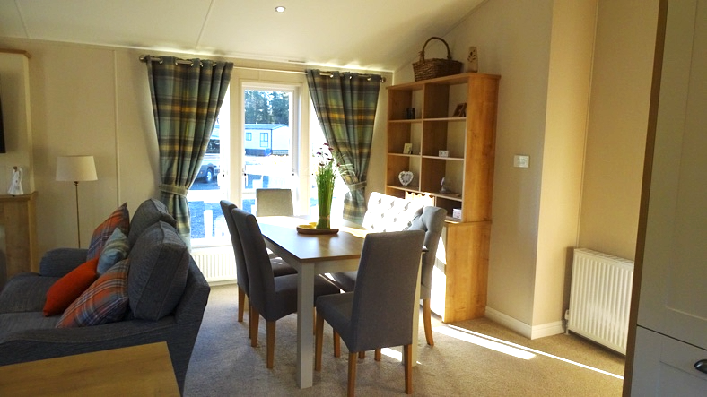

Dining Area: Set to the rear of the lounge the dining table provides seating for six people, with windows to the side and a display cabinet. A perfect space for entertaining family and guests.
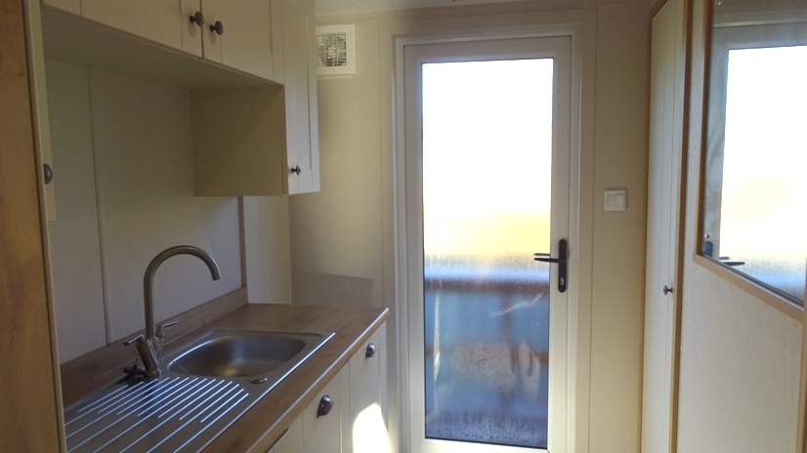
Utility Room: providing the side entrance door, integrated washing machine, single drainer sink unit, cupboards and worktops. cupboard housing the LPG central heating boiler.

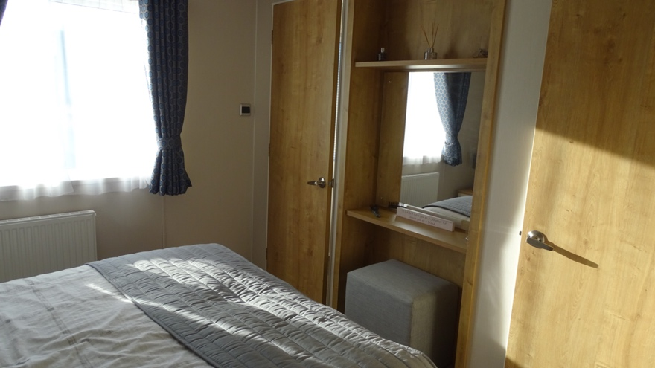
Bedroom 1: bed with cabinets each side, window to side, vanity unit with shelving and mirror. TV connections . Dressing Room with hanging shelving and drawers.
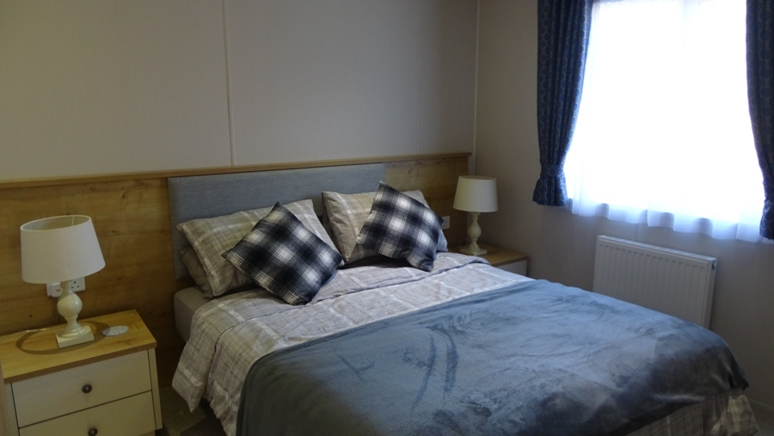
Master En-Suite with corner shower, w/c and wash hand basin.
Bedroom 2 Double bed with cabinets to each side, window to side, vanity shelf with mirror, wardrobe and TV connection.

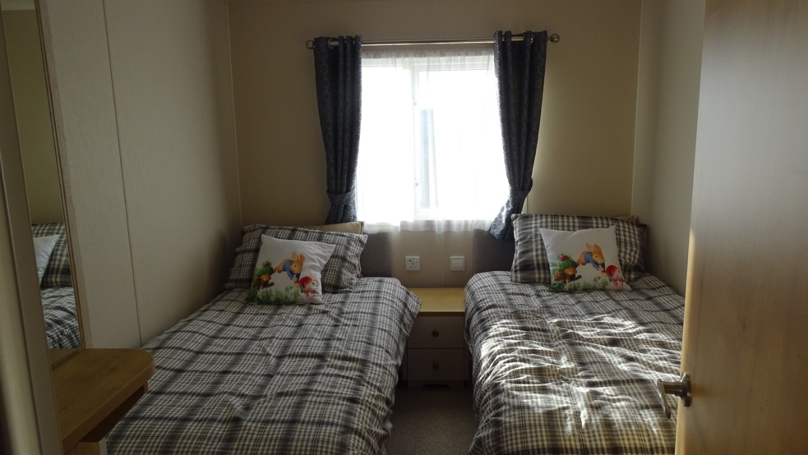
Bedroom 3: Two twin beds, with cabinet between, wardrobe, window to side

Family Bathroom Room: Obscure window to side, full size bath vanity wash hand basin with cupboard below. w/c.

Outside: timber decking overlooking Loch Murray, the decking runs along the side of the lodge to a second seating area. Back to the front and down a couple of steps there is a private Hot Tub also facing the loch to enjoy soaked up evenings and a glass of wine.

We think you will enjoy the lifestyle this family lodge has to offer.

NB. This is a brokerage sale, Viewing is highly recommended to appreciate the quality of this unit.

Viewing by appointment only

Please contact either

Alister on 07484 161500
or
Gillian on 07359 461297

who will be delighted to answer any questions or show you around this lovely unit

Castle Cary Holiday Park

Owning a Static caravan, a lodge or a log cabin is a lifestyle choice, a home away from home, if you are looking at owning the perfect getaway Castle Cary Holiday Park is the ideal location for you and is also close to the Dumfries & Galloway coastline,

With the romantic backdrop of an ancient castle dating from around the late 1400s to early 1500s with its service wing now incorporates The Lairds Inn the parks very own public house/Restaurant with its ‘olde worlde` charm that offers a delicious culinary menu.

There is also a Café on site serving hot and cold food and beverages Two heated swimming pools, one of which is outdoors and enclosed so perfect for catching the sun. For the younger children there is a playpark and games room to keep them occupied for hours on end.

Adjacent to the park is wonderful ancient woodland offering walks a plenty for you and your four-legged family member with access to the village of Creetown.

We would be delighted to talk to you about owning your own holiday home here at Castle Cary and look forward to showing you the units we have on offer at our lovely holiday park. you will not be disappointed.

At Castle Cary holiday Park we like to be transparent in all our fee’s
so, there will be no unexpected charges.

Holiday Homes and Lodges

Seasonal Holiday Homes
8 Month Season  1st March 2026 to 31st October 2026  Site Fees £2055.90 + VAT  Rates from £275.00 + VAT  Refuse / Water £125.00 + VAT  Electricity by Meter | 11 Month Season  1st March 2026 to 31st January 2027  Site Fees £2272.20 + VAT  Rates from £275.00+ VAT  Refuse / Water £161.86 + VAT  Electricity by Meter

Single Lodges / Residential Specification Holiday Homes
8 Month Season  1st March 2026 to 31st October 2026  Site Fees £2208.53 + VAT  Rates from £330.00 + VAT  Refuse / Water £125.00 + VAT  Electricity by Meter | 11 Month Season  1st March 2026 to 31st January 2027  Site Fees £2447.00 + VAT  Rates from £330.00+ VAT  Refuse / Water £161.86 + VAT  Electricity by Meter

Twin Lodges
8 Month Season  1st March 2026 to 31st October 2026  Site Fees £242153+ VAT  Rates from £368.50 + VAT  Refuse / Water £125.00 + VAT  Electricity by Meter | 11 Month Season  1st March 2026 to 31st January 2027  Site Fees £2754.92 + VAT  Rates from £368.50+ VAT  Refuse / Water £161.86 + VAT  Electricity by Meter

Castle Cary Holiday Park, The Meadows, Creetown, Newton Stewart

